In 2011 a continental, and largely Mediterranean, shieldbug was found in Kent: Rambur’s Pied Shieldbug (Tritomegas sexmaculatus). Since then, this species has made a steady advance north-west and has since been found in an increasing number of locations in Kent and towards London.

The species is very similar to the commoner and closely related Pied Shieldbug (Tritomegas bicolor). The main differentiating characteristics for the adult bugs are more extensive white patches on the pronotum (the armoured section immediately behind the head and before the wing cases begin) and the darker (black) wing membrane at the bottom centre of the bug in the case of Rambur’s.

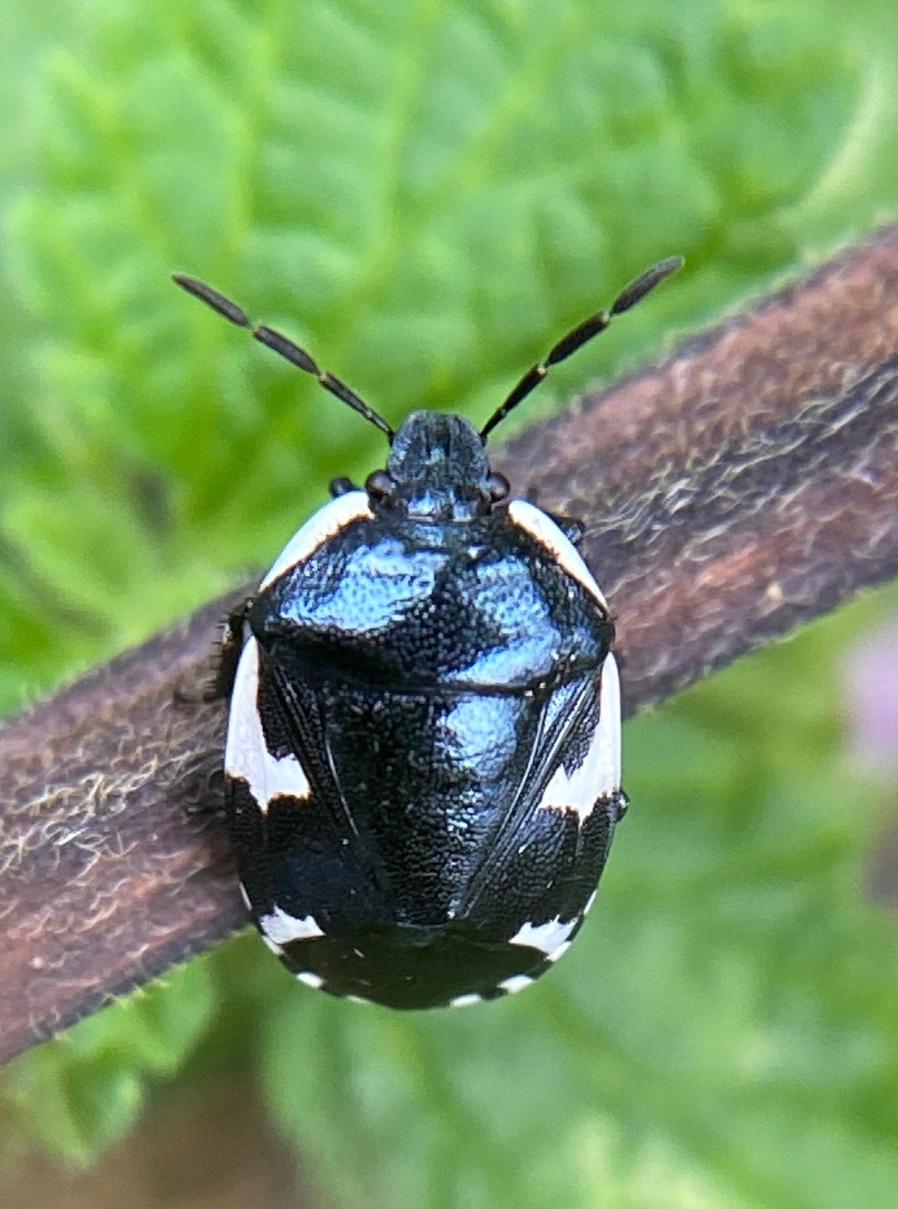

In August we were contacted by someone studying and mapping the spread of this species, partly to see if it had got as far north and west as Wanstead Flats yet. That individual later came herself and found the species on its host plant, Black Horehound (Ballota nigra).

For me, and at least one other Wren member, the news of a national rarity found on our patch was too tempting an opportunity and we both went separately and found bugs of different stages of maturity ourselves.

This map from iRecord shows the progression of the species up towards London - with all the red dots being records of this species. At the time of submitting my own records, Wanstead Flats was the most northerly and western location Rambur’s Pied Shieldbug had ever been found. We now expect to hear of records further in to London and the country.

The spread of this species is likely to be a result of the warming climate and similar movements can be seen across a range of other species.

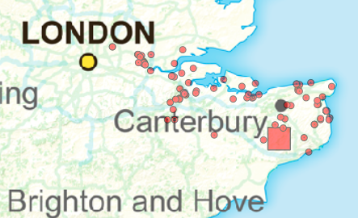

If you are out and about and find Black Horehound, do check it for this extremely smart new addition to our Hemipteran fauna.

